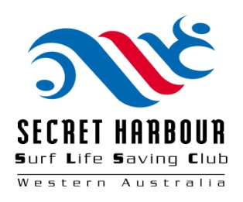
Secret Harbour Surf Life Saving Club
Membership Application Form

SURNAME __________________________________ FIRST NAME __________________________________

ADDRESS __________________________________________________________________________________

SUBURB _____________________________________________________ POST CODE ________________

PHONE (Home) ___________________________ PHONE (Mobile) __________________________________
(If known for renewal)
MEMBERSHIP NO. ______________________________________________ D.O.B _____________________
Please indicate:
EMAIL _________________________________________________________________ MALE / FEMALE

MEMBERSHIP TYPE (eg Social/Active/General (Nipper parent)/Honorary: _______________________________________________________________________________________

If the application is for a FAMILY please complete this section for each family member
other than the main member named above.

Member’s  First Name | Member’s  Surname | Spouse / Child | Date of  Birth | Male / Female

- I hereby apply for Membership of the Secret Harbour SLSC.
- I wish for my email address to be used as my address in the Club Members Register.
- I understand that my rights and privileges do not commence until my application is approved.
- I will abide by all the Rules and Regulations of the Secret Harbour SLSC.
- I have a FOB for access to the Surf Club
- I have a current Working with Children card.

Date: _____ / _____ / _____ Signature: ________________________________________

Office use only
Receipt Number _______________ Amount Paid _______________ Membership Type ________________
Receipt Date __________________ Payment by ________________

